Exercise 6-1

a)

Given that the selected individual purchased an extra battery, what is the probability that an optional card was also purchased?

The two events are not independent, because:

$$Pr\left(A∩B\right)≠\operatorname{Pr}\left(A\right)⋅Pr⁡(B)$$

The probability of $A$ occurs if $B$ occurs:

$$\operatorname{Pr}\left(A | B\right)=\frac{Pr\left(A∩B\right)}{\operatorname{Pr}\left(B\right)}=\frac{0.3}{0.4}=75\%$$

b)

Given that the selected individual purchased a memory card, what is the probability that an optional extra battery was also purchased?

The two events are not independent, because:

$$Pr\left(A∩B\right)≠\operatorname{Pr}\left(A\right)⋅Pr⁡(B)$$

The probability of $A$ occurs if $B$ occurs:

$$\operatorname{Pr}\left(B | A\right)=\frac{Pr\left(A∩B\right)}{\operatorname{Pr}\left(A\right)}=\frac{0.3}{0.6}=50\%$$

Exercise 6-2

If a randomly selected individual is tested and the result is positive, what is the probability that the individual has the disease?

Probability that someone is 1/1000 and the test is true positive:

$$Pr\left(A\right)=0.001⋅0.99=0.00099$$

Probability that someone is false positive:

$$\operatorname{Pr}\left(B\right)=0.02$$

$$\operatorname{Pr}\left(not B\right)=0.98$$

$$\operatorname{Pr}\left(A\right|not B)=\frac{Pr⁡(A∩not B)}{Pr⁡(not B)}=\frac{0.00099⋅0.98}{0.98}=0.00099=0.099\%$$

Exercise 6-3

(a)

When k = 4 The triangle is a circle

(b)

When k = 7 The triangle is a circle

(c)

When k = 10 The triangle is a square

Exercise 6-4

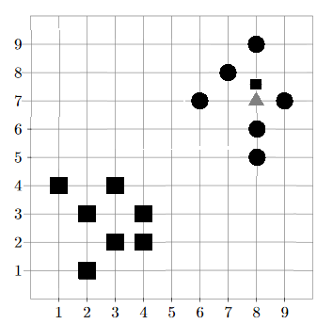

The triangle would be classified as a square, even though it intuitively is a circle.

Exercise 6-5